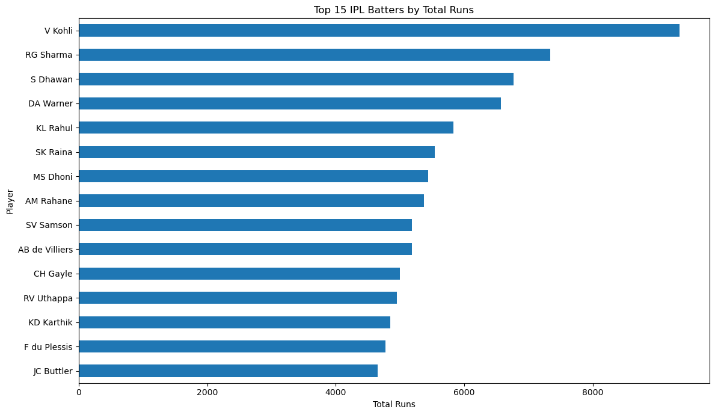
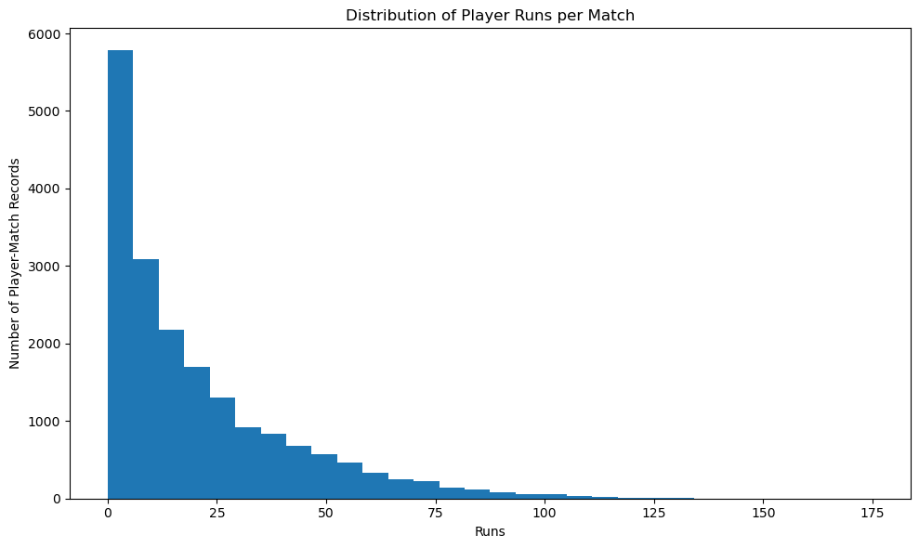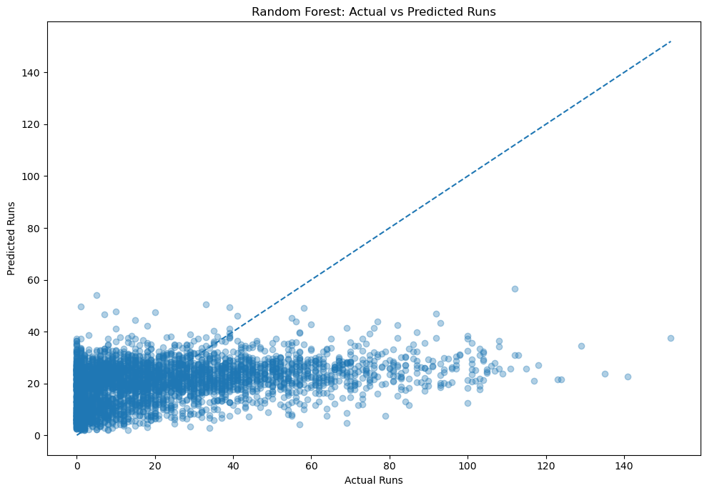
 | Feature | Importance
685 | numerical__career_average_before_match | 0.303266
688 | numerical__recent_10_match_average | 0.073073
686 | numerical__career_strike_rate_before_match | 0.071691
690 | numerical__previous_matches | 0.057706
689 | numerical__opponent_average_before_match | 0.056808
684 | numerical__previous_strike_rate | 0.054969
687 | numerical__recent_5_match_average | 0.048156
683 | numerical__previous_runs | 0.043932
693 | numerical__recent_5_fours | 0.040253
694 | numerical__recent_5_sixes | 0.030183
691 | numerical__previous_fours | 0.019890
682 | numerical__innings | 0.015639
692 | numerical__previous_sixes | 0.010141
274 | categorical__batter_KL Rahul | 0.005250
654 | categorical__opponent_Kings XI Punjab | 0.004631
658 | categorical__opponent_Mumbai Indians | 0.004226
664 | categorical__opponent_Royal Challengers Bangalore | 0.004191
666 | categorical__season_2007/08 | 0.004114
661 | categorical__opponent_Rajasthan Royals | 0.004098
656 | categorical__opponent_Kolkata Knight Riders | 0.003484
